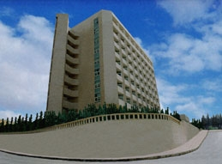
Amman Cham Palace

Amman Cham Palace rated four star hotel, situated in Shmeisani, in Amman’s thriving business and shopping district, is just a 5-minute walk away from the city’s main commercial region. Queen Alia International Airport is 25 minutes from the hotel.

ACCOMODATION:

The hotel has 140 deluxe rooms including 3 suites. Each spacious room displays a magnificent view of the capitol, Amman. All rooms and suites are tastefully decorated and equipped with modern accessories, Internet access, safe box and of course for the business man’s convenience, a trouser press ,Do not forget our Swimming Pool for your relaxation and refreshing Cocktails, what a better way to take a break from business

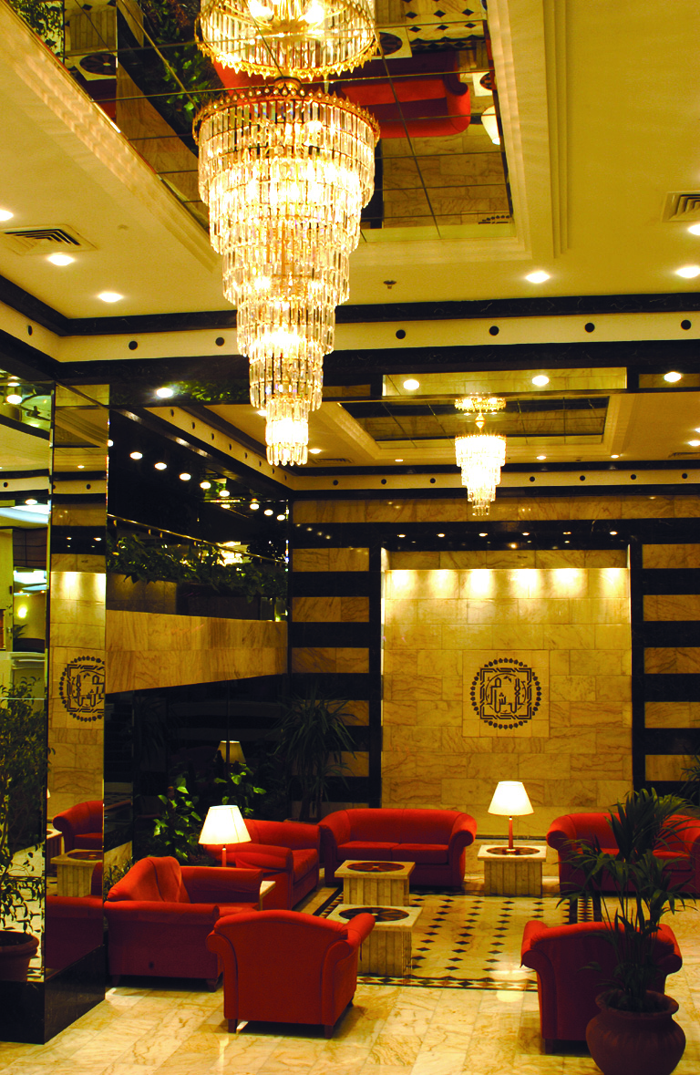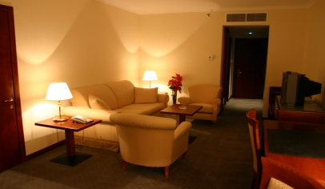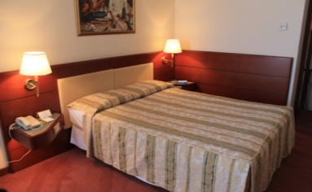

CONFERENCE AND BANQUET FACILITIES:

Amman Cham Palace offers functionally designed facilities for business and social gatherings that can accommodate up to 200 guests. Whether planning a board meeting, seminar or banquet, be assured of our complete dedication to making your event with us a most enjoyable and memorable occasion Our team will guide you through the event planning, from specialty menus to the use of state of the art audio/visual equipment. Every detail will receive professional, personalized attention turning your event into a definite success.

70 JOD | Standard Single Room On B/B Basis
80 JOD | Standard Double Room On B/B Basis
140 JOD | Junior Suite On B/B Basis

Kindly note that
The above rates are per Room on B/B basis in Jordanian Dinars and including all tax and services with an unlimited internet access.

RESTAURANTS AND BARS:

CAFÉ HEDIARD, the French Café and Boutique along with its terrace and bar, boasts a mixture of the warm, local atmosphere followed by an everlasting touch of Parisian products

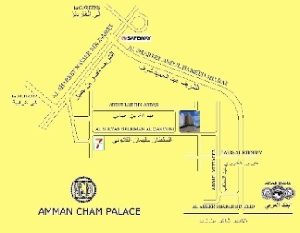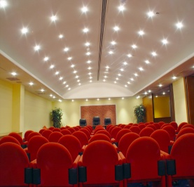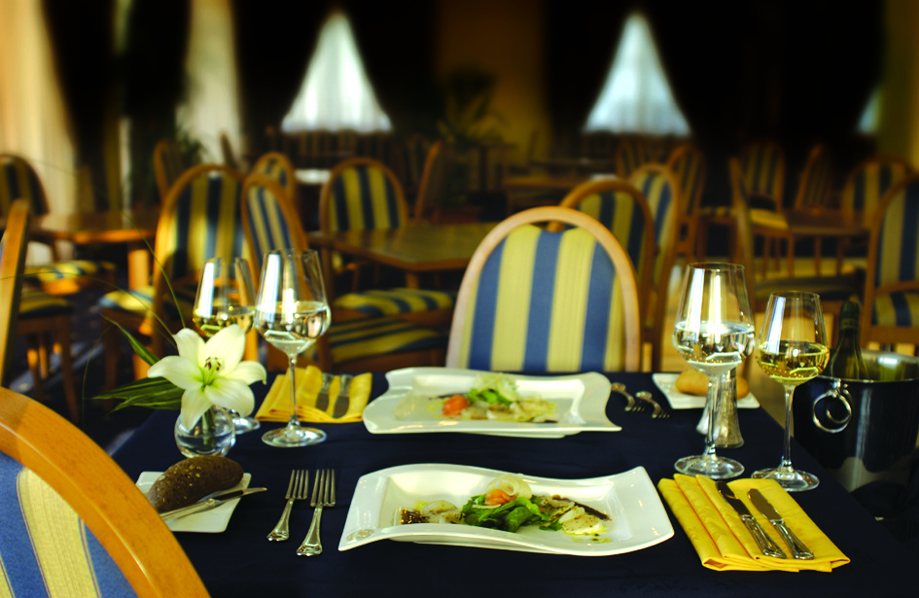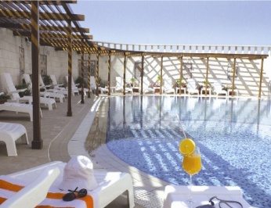

Our Palace is your Palace

