How to reach to Fatih University?

FROM Istanbul Ataturk Airport (IST):
1) By Taxi Cab to Fatih Univ: Approx. 50 TL (25-30 Euros)
2) By Public Transportation: Take undrerground metro, get off at 2nd stop (Yeni Bosna), go to bus stop on E-5 to Edirne (west), as opposed to Istanbul (east), get on Hadimkoy Midibus (Blue, 418) that takes you to Fatih Univ.
3) As you see in the little map below, Hotels Radisson SAS (2-3 stops from Yeni Bosna, close to airport), Hotel Beynova (after Bauhaus) and Kaya Ramada are all on the sideline of E-5. You can use Hadimkoy Midibus (Blue, 418) to go between Fatih Univ and any of these hotels.

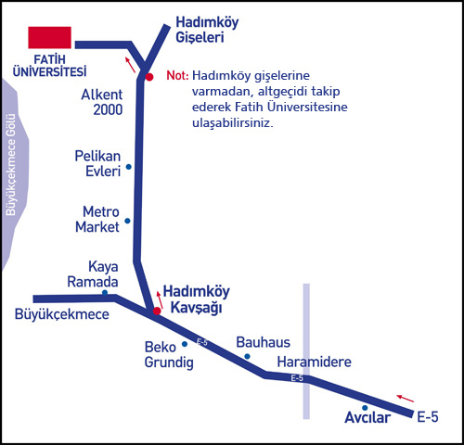Yeni Bosna

